Node.js

What is Node.js

* Node.js is a runtime environment which can run the Javascript code outside the browser
* Before Node.js, you could run the Javascript only using browser, Javascript was used only at the front-end to provide UI logics like adding effects to the UI, making the UI content dynamic
* With the help of Node.js you can now write Javascript for the backend applications that can interact with various resources like files, databases, buffers and so on

Node.js architecture

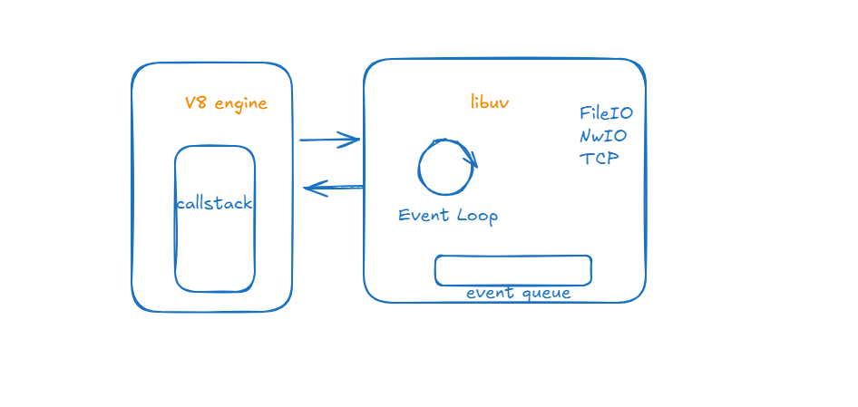

Node.js has 2 main components

V8 engine: It is Google high performance engine which converts Javascript code to Machine code.

Libuv: It mainly handles asynchronous IO operations

What is IO

IO refers to the programs interaction with the

* System Disks
* Network
* Read/Write files
* Talking to the DB
* Making HTTP Requests

These programs are slow compared to the CPU work or accessing memory

What are Synchronous & Asynchronous operations

* Synchronous operations: These are the operations that are executed sequentially one at a time

let result = connect(“www.foo.com/xyz”);

console.log(result);  
console.log(“Done”);

Note: The program runs sequentially by first printing the result & then Done

* Asynchronous operations: These are the operations which are independent from the primary program flow & this will let primary program to continue without waiting for the operations to complete

connect(“www.foo.com/xyz”, (result) => console.log(result));  
console.log(“DONE”);

Note: The program prints the DONE first and the result once the asynchronous operation is completed

ex: setTimeout(), db related functions()

Node.js has V8 & Libuv, the V8 is the one which takes care of running your javascript code, it is single threaded

Libuv has many programs like Event Queue, Event Loop, TCP/IP, File IO, N/W IO and etc., these are handled by system threads, they don’t execute the Javascript code user has written, these programs are asynchronous which are implemented using C/C++ & exposed as a Javascript functions, some the functionalities are setTimeout, setInterval(), fs.readFile(), fs.writeFile(), app.get(), app.post() and etc these are all asynchronous methods which are written in C/C++ & provided as Javascript functions

console.log(“first line”);  
setTimeout(() => { some code }, 1000);  
consoe.log(“second line”);

Output:

first line  
second line  
some code

Note: Even if we give 0 in the setTimeout the callback of the setTimeout is executed once the call-stack of V8 is empty or once its pushed to the call-stack after the event loop makes a trip

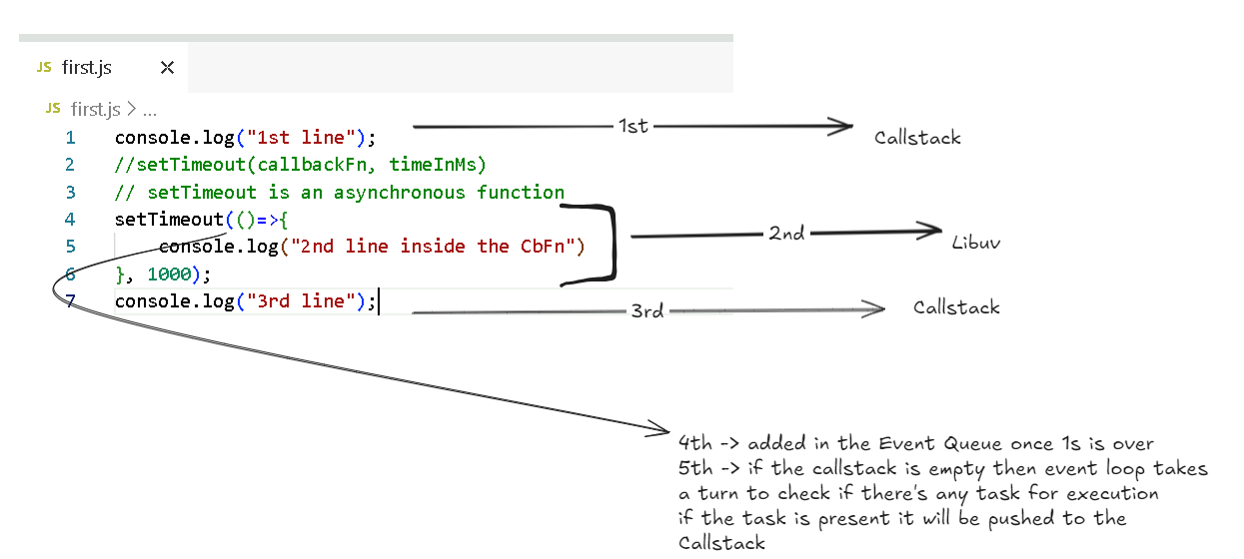

Output:

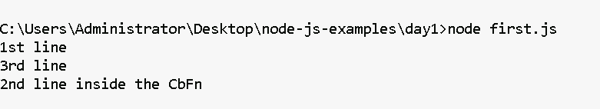

Even if you give 0 in the setTimeout, it wouldn’t be executed immediately, because the setTimeout() function is handled by libuv & the task is added to the event queue after the timer completes whether its 0 or 1000ms, then the event loop makes a trip to check if the event queue has any task for V8 engine to execute.

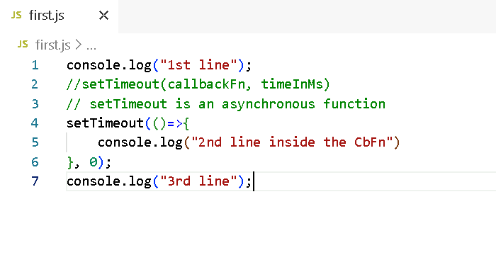

Output:

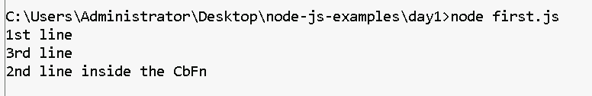

Global Objects

Node.js has 1000’s of objects in many node.js modules like

process  
console  
Buffer  
setTimeout  
setInterval  
setImmediate  
and many more

Node.js uses a configuration file called package.json which an heart of every node.js project, if you don’t have this you can create using npm init option

How to create package.json

npm init

or

npm init -fy (force yes)

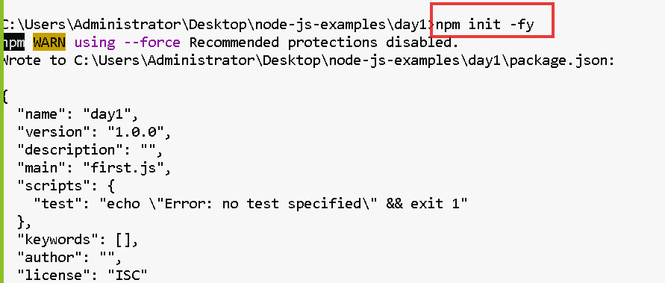

Note: By default node.js uses ES5 module to import

i.e.,

let fs = require(“fs”);

However you can configure package.json to use ES6 modules to import or export

i.e.,

import fs from ‘fs’;

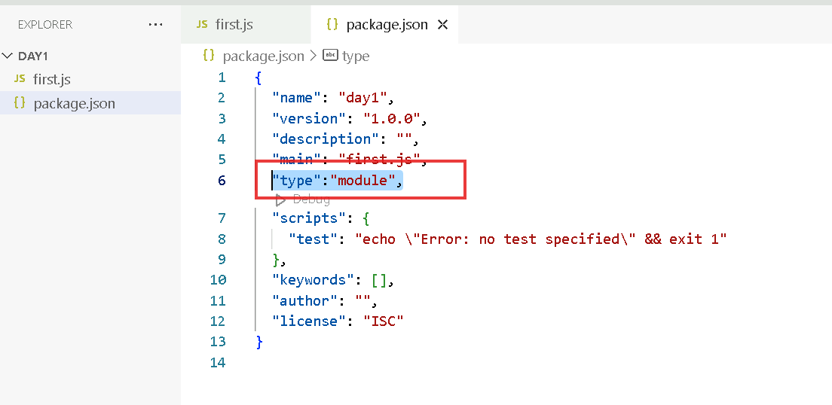

How to export & import the modules in Node.js

hello.js  
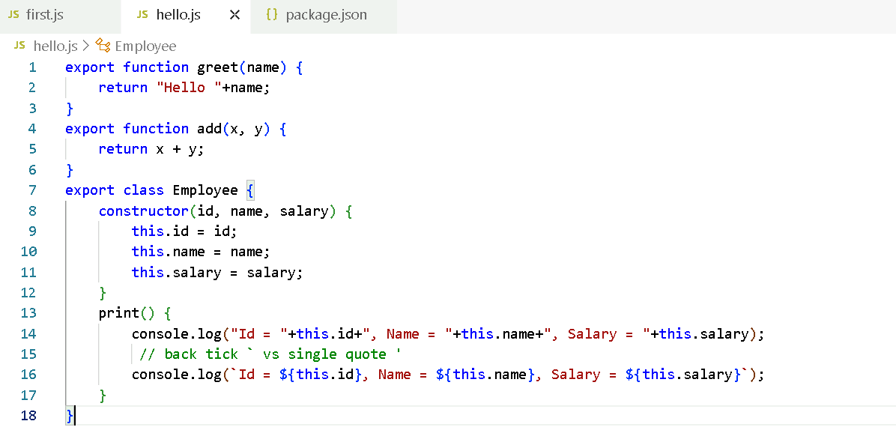

first.js

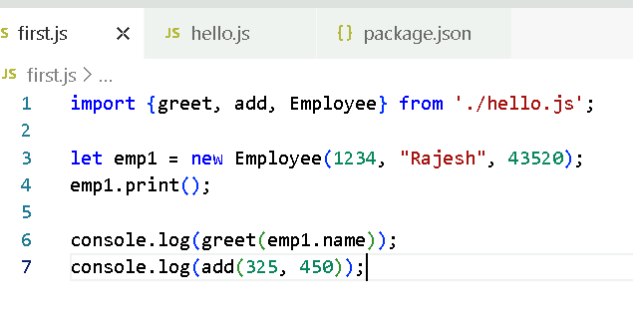

The above modules are imported in {} because they are named modules, in Javascript we have default module that can be imported with any name but we must not use { }

Note: In a single javascript you can have maximum one default export & any number of named exports

export default function app() { … }

import app from ‘./file.name.js’

or

import x from ‘./file.name.js’;

hello.js

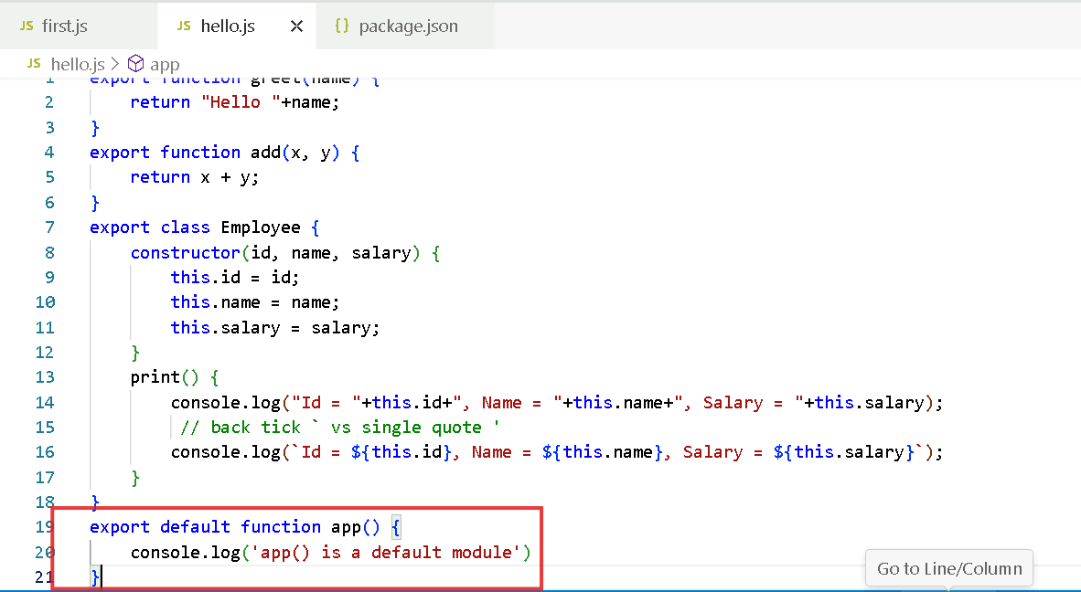

first.js

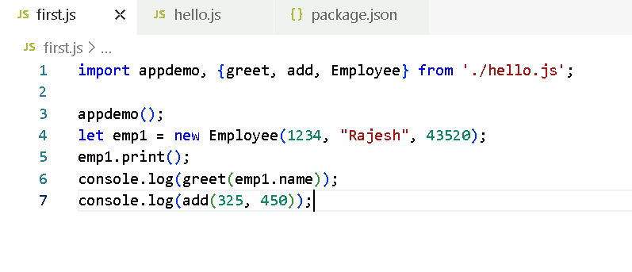

Note: In Javascript you create default modules when a main functionalities needs to be added in the module, ex:

axios library of React.js has a default module that provides methods to access backend

React.js library has a default module that provides functionalities to create UI’s

Express.js library has a default module that provides function to create an object & access HTTP methods

What if there are 2 modules with the same name in different Javascript file, how does the node.js resolves these modules

Activity: Create a.js & b.js and in both the files create same named export function & in c.js try to import the functions present in the a.js & b.js and call them in c.js

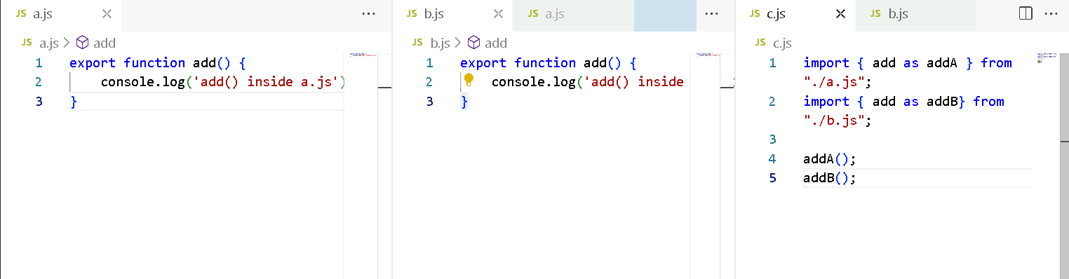

Old style of exporting & importing

exports.add = function(x, y) { … } // or module.exports.add = function (x, y) { … }

let add = require(“./file.js”).add;

New style of exporting & importing

export function add(x, y) { }   
import { add } from ‘./file.js’;

process.nextTick(callbackFn):

It is executed automatically when event loop takes a turn

setImmediate(callbackFn): This similar to setTimeout() which is executed immediately without any timer

but if you use setTimeout, you will use setTimeout(callbackFn, timer), however you can give 0 in the timer and make it work like setImmediate()

Summary:

* Node.js
* Node.js architecture (v8 & libuv)
* default & named exports
* package.json:
* process.nextTick, setImmediate, setTimeout

C++ Add ons

In Node.js many libraries which do asynchronous operations are written in C++, C++ add-ons provide an interface which makes Javascript functions & C++ to interact i.e., which are exposed as a Javascript functions.